

**DEPARTMENT OF COMPUTER SCIENCE AND DESIGN**

**ACADEMIC YEAR 2024-2025 ODD SEMESTER**



**CD23332**

**LAB MANUAL**

**SECOND YEAR**

**THIRD SEMESTER**

**2024- 2025**

**ODD SEMESTER**

|  |  |  |
| --- | --- | --- |
| **List of Experiments** | | |
| 1 | Design to teach mathematics to the children of 4-5 years age in school in Rural sector | |
| 2 | Design to help people to sell their handmade products in metro cities | |
| 3 | Design a social media website and chat | |
| 4 | Design a publication that support different languages | |
| 5 | Design a publication that tells comic stories | |
| 6 | Design an advertisement for mobile company | |
| 7 | Design an advertisement for any political party with images | |
| 8 | Design an advertisement for electronic products | |
| 9 | Design an advertisement for food products | |
| 10 | Design an interactive website for new institution | |
| 11 | Design a blog that publish educational post | |
| 12 | Design an interactive website for hospital management system | |
| 13 | Design an interactive website for food selling app | |
| **Requirements** | | |
| Hardware | | Intel i3 or AMD processor with 64-bit support;2 GHz or faster processor with SSE 4. or later- 8 GB RAM -Windows 10 64-it (version 1909)or later - 1.5 GB of GPU memory -4 GB of available hard-disk space |
| Software | | Figma, Adobe Photoshop, HTML and CSS |
| Operating System | | Windows |

**LAB PLAN**

**CD23332-DESIGN PROCESSES AND PERSPECTIVES LAB**

|  |  |  |
| --- | --- | --- |
| **Exercise no.** | **Exercise Name** | **Required Hours** |
| 1 | Design to teach mathematics to the children of 4-5 years age in school in Rural sector | 3 |
| 2 | Design to help people to sell their handmade products in metro cities | 6 |
| 3 | Design a social media website and chat | 3 |
| 4 | Design a publication that support different languages | 3 |
| 5 | Design a publication that tells comic stories | 3 |
| 6 | Design an advertisement for mobile company | 3 |
| 7 | Design an advertisement for any political party with images | 9 |
| 8 | Design an advertisement for electronic products | 6 |
| 9 | Design an advertisement for food products | 6 |
| 10 | Design an interactive website for new institution | 6 |
| 11 | Design a blog that publish educational post | 6 |
| 12 | Design an interactive website for hospital management system. | 3 |
| 13 | Design an interactive website for food selling app. | 3 |

**Course Outcomes (COs)**

**Course Name: Design Processes and Perspectives Course Code: CD19341**

|  |  |
| --- | --- |
| Outcome 1 | Understand the various graphic design thinking process and phases |
| Outcome 2 | Analyze and choose between various visual components |
| Outcome 3 | Designing and communicating visual components |
| Outcome 4 | Apply design concepts for media publishing and advertising |
| Outcome 5 | Create website using different design concepts |

# CO-PO –PSO matricesofcourse

|  |  |  |  |  |  |  |  |  |  |  |  |  |  |  |  |
| --- | --- | --- | --- | --- | --- | --- | --- | --- | --- | --- | --- | --- | --- | --- | --- |
| PO/PSO  CO | PO 1 | PO 2 | PO 3 | PO 4 | PO 5 | PO 6 | PO 7 | PO 8 | PO 9 | PO 10 | PO 11 | PO 12 | PSO 1 | PSO 2 | PSO 3 |
| CD19341.1 | 3 | 1 | 3 | 2 | 3 | 2 | 3 | 2 | 1 | 1 | 1 | 3 | 1 | 3 | 1 |
| CD19341.2 | 3 | - | 3 | - | 3 | - | - | - | - | - | 1 | 1 | 1 | 3 | 1 |
| CD19341.3 | 3 | 3 | 3 | 2 | 3 | - | - | - | - | - | - | 1 | 1 | 3 | 2 |
| CD19341.4 | 1 | 3 | 3 | 3 | 3 | 3 | 2 | 2 | 2 | 2 | 2 | 2 | 1 | 3 | 3 |
| CD19341.5 | 1 | 3 | 3 | 3 | 3 | 3 | 2 | 2 | 2 | 2 | 2 | 2 | 1 | 3 | 3 |
| Average | 2.2 | 2.0 | 3.0 | 2.0 | 3.0 | 1.6 | 1.4 | 1.0 | 1.0 | 1.0 | 1.2 | 1.8 | 1.0 | 3.0 | 2.0 |

Note: Enter correlation levels 1,2 or 3 as defined below:

1: Slight(Low) 2: Moderate(Medium) 3: Substantial(High) If there is no correlation, put “-“

**Expt. No.:1**

**Date:**

**Design to teach mathematics to the children of 4-5 years age in school in Rural sector**

**Aim:** To design a user interface for teaching mathematics to the children of 4-5 years age in school in the rural sector.

**Tools:** Figma, Photoshop

**Steps:**

1. Create a new background layer.
2. Create containers for placing images, icons and logos.
3. Gradient color panel has to be used.
4. Buttons and attractive fonts have been used.
5. Proper navigation should be done to move from one page to another.
6. Login page has to be included

**Output:**

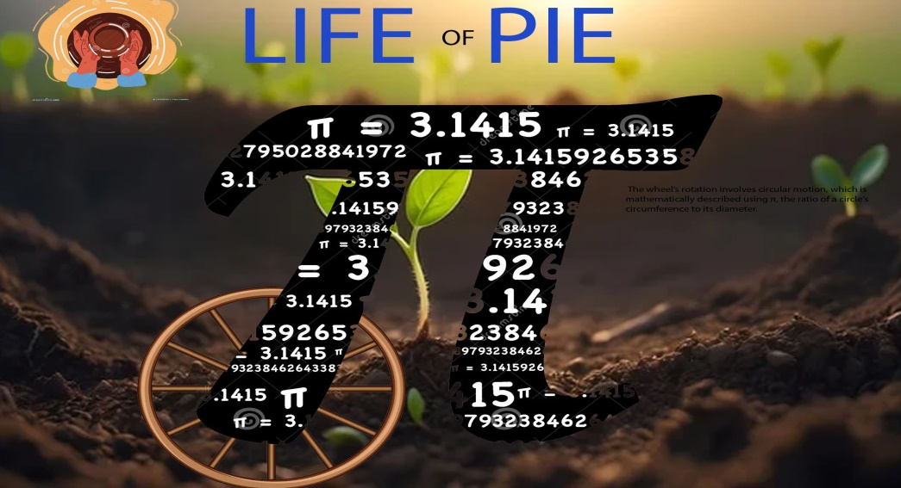

**Result**

**:**

**This visually engaging design creatively incorporates mathematical concepts like π to captivate young students in rural schools.**

**Expt. No.:2**

**Date:**

**Design to help people to sell their handmade products in metro cities**

**AIM:** To Design an UI that can help people to sell their handmade products in metro cities

**Tools:** Figma, Photoshop

**Steps:**

1. Create a new background layer.
2. Create containers for placing images, icons and logos.
3. Gradient color panel has to be used.
4. Buttons and attractive fonts have been used.
5. Proper navigation should be done to move from one page to another.
6. Login page has to be included.

**Output:**

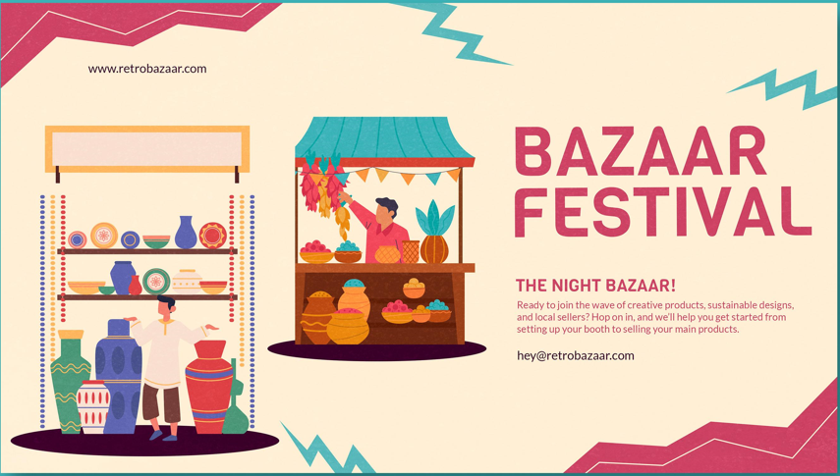

**Result:**

**The vibrant, illustrative design effectively communicates the festive, handcrafted "Bazaar Festival" through its strategic use of color, composition, iconography, and typography.**

**Expt. No.:3**

**Date:**

**Design a social media website and chat**

**Aim:** To design a user interface for teaching mathematics to the children of 4-5 years age in school in the rural sector.

**Tools:** Figma, Photoshop

**Steps:**

1. Create a new background layer.
2. Create containers for placing images, icons and logos
3. Gradient color panel has to be used
4. Buttons and attractive fonts have been used
5. Proper navigation should be done to move from one page to another
6. Login page has to be included

**Output:**



**Result:**

**A social media website and chat that helps businesses grow their online presence and engage with customers.**

**Expt. No.:4**

**Date:**

**Design a publication that support different languages**

**Aim:** To design a publication that support different language

**Tools:** Adobe Photoshop

**Steps:**

1. Create a new background layer.
2. Create containers for placing images, icons and logos
3. Gradient color panel has to be used
4. Use different languages to display the content.
5. Use images that support the content.
6. Align white spaces between the contents.

**Output:**

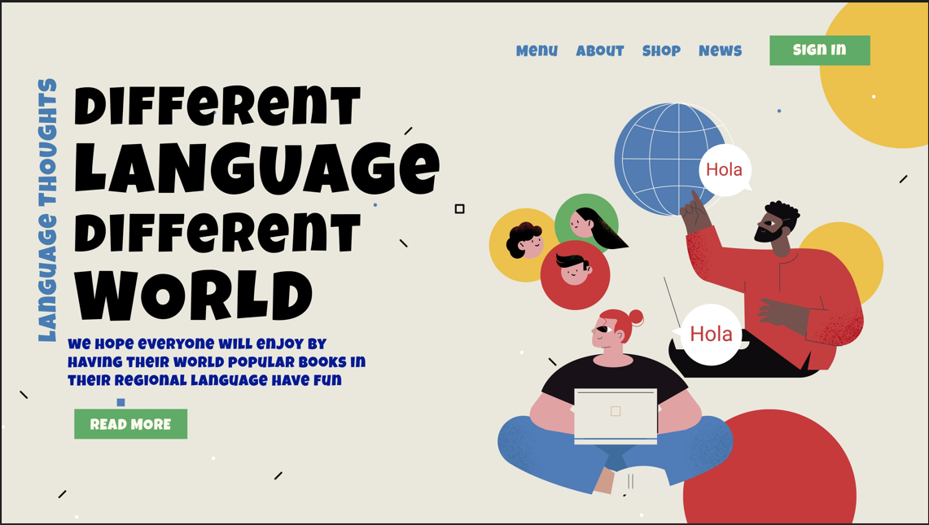

**Result:**

**A multilingual publication platform that supports diverse language editions and global audience engagement.**

**Expt. No.:5**

**Date:**

**Design a publication that tells comic stories**

**Aim:** To design a Publication That Tells Comic Stories

**Tools:**  Adobe Photoshop

**Steps:**

1. Create a new background layer.

2. Create containers for placing images, icons and logos

3. Gradient color panel has to be used.

4. Use different languages to display the content.

5. Use images that support the content.

6. Align white spaces between the contents.

**Output:**

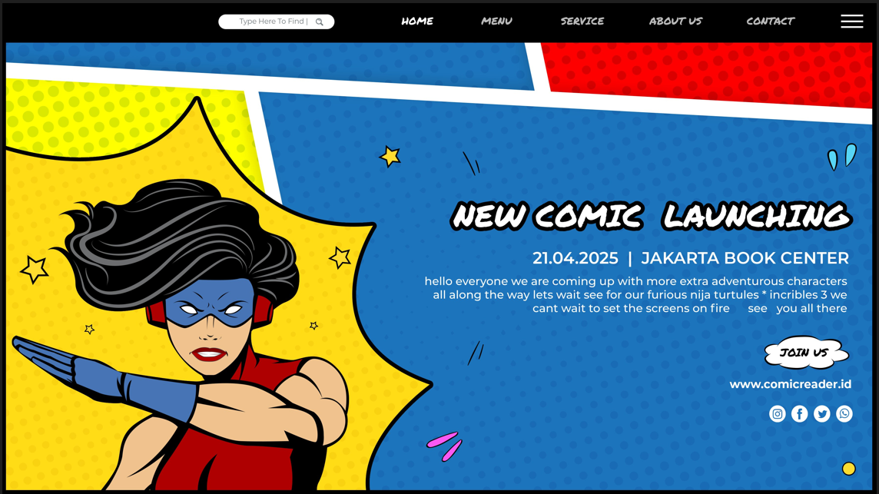

**Result:**

**Comic book website design with a unique, eye-catching layout showcasing the upcoming comic's artwork and story.**

**Expt. No.:6**

**Date:**

**Design an advertisement for mobile company**

**Aim:** To design an advertisement for mobile company

**Tools:**  Adobe Photoshop, Canva

**Steps:**

1. Create a new background layer.

2. Create containers for placing images, icons and logos

3. Gradient color panel has to be used

4. Images that support the context must be placed.

5. Written context must be emphasized.

6. Appropriate color palette must be used

**Output:**

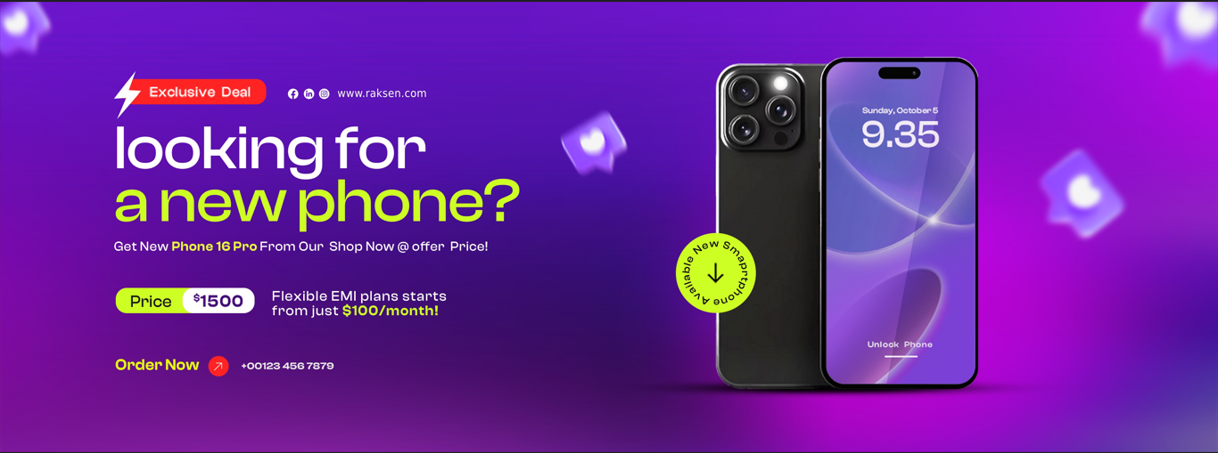

**Result:**

**A sleek, modern smartphone advertisement highlighting cutting-edge features, exclusive offers, and a strong call to action.**

**Expt. No.:7**

**Date:**

**Design an advertisement for any political party with images**

**Aim:** To design an advertisement for any political party with images

**Tools:**  Adobe Photoshop, Canva.

**Steps:**

1. Create a new background layer.

2. Create containers for placing images, icons and logos.

3. Gradient color panel has to be used.

4. Images that support the context must be placed.

5. Written context must be emphasized.

6. Appropriate color palette must be used.

**Output:**

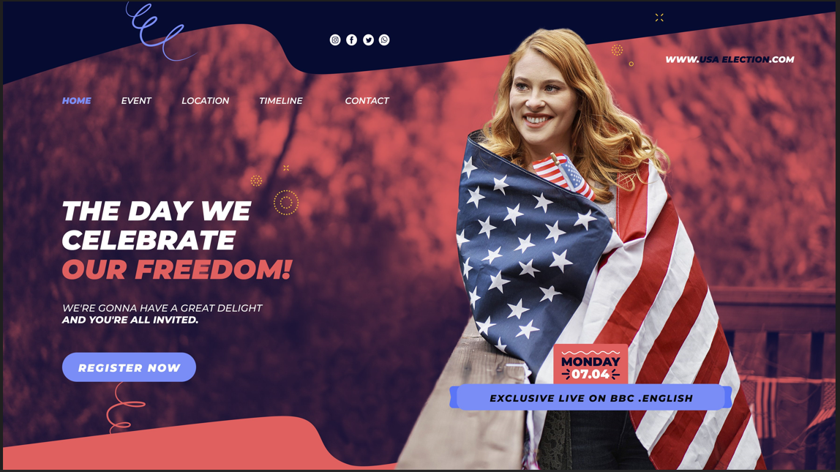

**Result:**

A powerful image of a united community, rallying behind a strong leader, promising a better future

**Expt. No.:8**

**Date:**

**Design an advertisement for electronic products**

**Aim:** To design an advertisement for electronic products

**Tools:**  Adobe Photoshop, Canva

**Steps:**

1. Create a new background layer.

2. Create containers for placing images, icons and logos.

3. Gradient color panel has to be used .

4. Images that support the context must be placed.

5. Written context must be emphasized.

6. Appropriate color palette must be used.

**Output:**

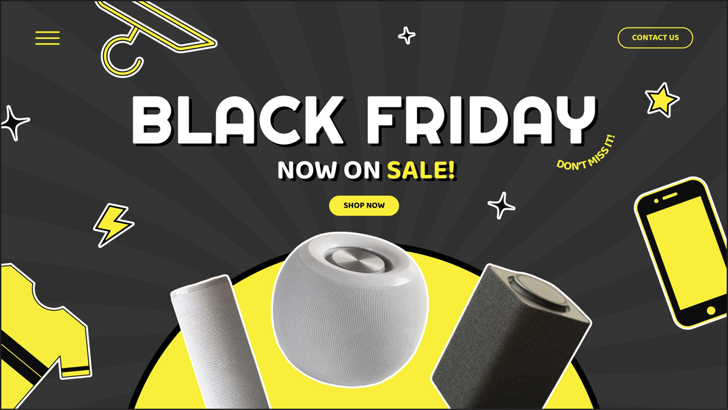

**Result:**

A dynamic and energetic Black Friday sale banner, featuring a bold, eye-catching design with vibrant colors and playful graphics.

**Expt. No.:9**

**Date:**

**Design an advertisement for food products**

**Aim:** To design an advertisement for food products

**Tools:**  Adobe Photoshop, Canva

**Steps:**

1. Create a new background layer.

2. Create containers for placing images, icons and logos.

3. Gradient color panel has to be used .

4. Images that support the context must be placed.

5. Written context must be emphasized.

6. Appropriate color palette must be used.

**Output:**

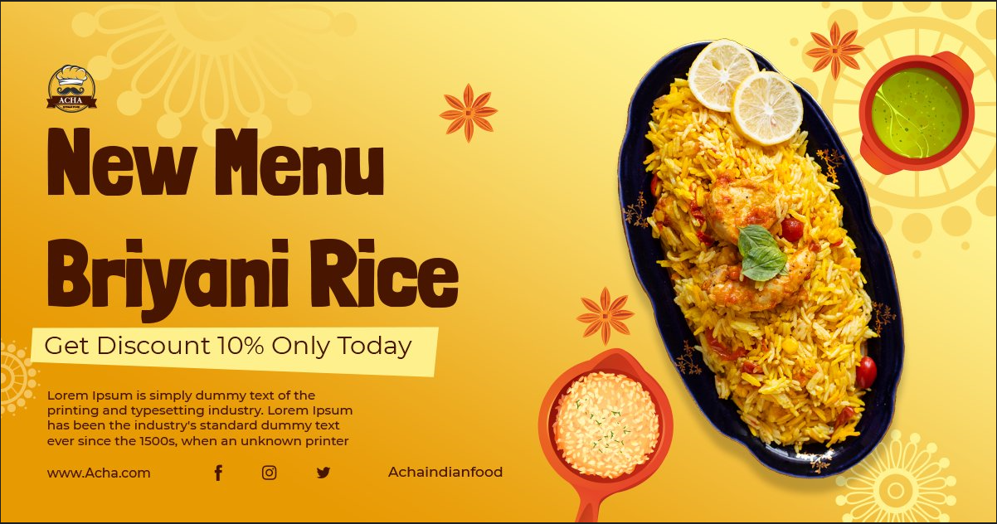

**Result:**

A vibrant and appetizing food advertisement, featuring a mouthwatering image of Biryani Rice. The design emphasizes the dish's rich flavors and enticing aroma, with a bold headline and a strong call to action.

**Expt. No.:10**

**Date:**

**Design an interactive website for new institution**

**Aim:** To design interactive website for new institution

**Tools:** HTML, CSS

**Steps:**

1. Create a document of type HTML.

2. Craft a style sheet for better design.

3. Include the link of the stylesheet to the HTML file.

4. Assign a title for each page.

5. Add the required styles and attributes for the HTML tags.

6. Include action tag to navigate from one page to another.

**Output:**

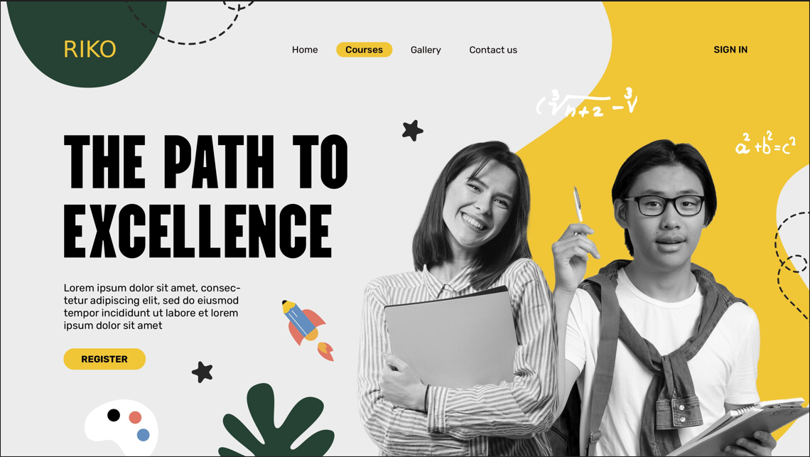

**Result:**

A sleek and modern website design with a user-friendly interface, featuring a clean layout and intuitive navigation. The website would incorporate interactive elements such as progress bars, animated charts, and personalized result dashboards.

**Expt. No.:11**

**Date:**

**Design A Blog That Publish Educational Post**

**Aim:** To design a blog that publishes educational post

**Tools:** HTML, CSS

**Steps:**

1. Create a document of type HTML.

2. Craft a style sheet for better design.

3. Include the link of the stylesheet to the HTML file.

4. Assign a title for each page.

5. Add the required styles and attributes for the HTML tags.

6. Include action tag to navigate from one page to another.

**Output:**

<!DOCTYPE html>

<html lang="en">

<head>

    <meta charset="UTF-8">

    <meta name="viewport" content="width=device-width, initial-scale=1.0">

    <title>LearnSphere - Educational Blog</title>

    <style>

        body {

            font-family: 'Arial', sans-serif;

            line-height: 1.6;

            margin: 0;

            background-color: #f4f4f4;

            color: #333;

        }

        .container {

            max-width: 1100px;

            margin: 0 auto;

            padding: 20px;

        }

        header {

            background-color: #3498db;

            color: white;

            text-align: center;

            padding: 20px;

        }

        .post-grid {

            display: grid;

            grid-template-columns: repeat(auto-fit, minmax(300px, 1fr));

            gap: 20px;

        }

        .blog-post {

            background-color: white;

            border-radius: 8px;

            box-shadow: 0 4px 6px rgba(0,0,0,0.1);

            overflow: hidden;

            transition: transform 0.3s;

        }

        .blog-post:hover {

            transform: scale(1.05);

        }

        .blog-post img {

            width: 100%;

            height: 250px;

            object-fit: cover;

        }

        .post-content {

            padding: 15px;

        }

        .post-meta {

            display: flex;

            justify-content: space-between;

            color: #777;

            font-size: 0.9em;

            margin-bottom: 10px;

        }

        .read-more {

            display: inline-block;

            background-color: #3498db;

            color: white;

            padding: 8px 15px;

            text-decoration: none;

            border-radius: 5px;

            margin-top: 10px;

        }

        footer {

            background-color: #2c3e50;

            color: white;

            text-align: center;

            padding: 15px;

            margin-top: 20px;

        }

    </style>

</head>

<body>

    <header>

        <h1>LearnSphere 📚</h1>

        <p>Your Gateway to Knowledge</p>

    </header>

    <div class="container">

        <div class="post-grid" id="blogPosts">

            <div class="blog-post">

                <img src="/api/placeholder/400/250" alt="Science Post">

                <div class="post-content">

                    <div class="post-meta">

                        <span>Science</span>

                        <span>July 15, 2024</span>

                    </div>

                    <h3>Understanding Quantum Physics</h3>

                    <p>An introduction to the fascinating world of quantum mechanics...</p>

                    <a href="#" class="read-more">Read More</a>

                </div>

            </div>

            <div class="blog-post">

                <img src="/api/placeholder/400/250" alt="Technology Post">

                <div class="post-content">

                    <div class="post-meta">

                        <span>Technology</span>

                        <span>July 10, 2024</span>

                    </div>

                    <h3>AI and Machine Learning</h3>

                    <p>Exploring the latest developments in artificial intelligence...</p>

                    <a href="#" class="read-more">Read More</a>

                </div>

            </div>

            <div class="blog-post">

                <img src="/api/placeholder/400/250" alt="Mathematics Post">

                <div class="post-content">

                    <div class="post-meta">

                        <span>Mathematics</span>

                        <span>July 5, 2024</span>

                    </div>

                    <h3>Advanced Calculus Concepts</h3>

                    <p>Deep dive into complex mathematical theories and applications...</p>

                    <a href="#" class="read-more">Read More</a>

                </div>

            </div>

        </div>

    </div>

    <footer>

        &copy; 2024 LearnSphere Educational Blog | All Rights Reserved

    </footer>

    <script>

        // Simple blog post addition functionality

        function addBlogPost(title, category, date, description) {

            const blogPosts = document.getElementById('blogPosts');

            const postDiv = document.createElement('div');

            postDiv.classList.add('blog-post');

            postDiv.innerHTML = `

                <img src="/api/placeholder/400/250" alt="${title}">

                <div class="post-content">

                    <div class="post-meta">

                        <span>${category}</span>

                        <span>${date}</span>

                    </div>

                    <h3>${title}</h3>

                    <p>${description}</p>

                    <a href="#" class="read-more">Read More</a>

                </div>

            `;

            blogPosts.appendChild(postDiv);

        }

        // Example of dynamically adding a post

        addBlogPost(

            'Programming Fundamentals',

            'Computer Science',

            'July 20, 2024',

            'Learn the basics of programming and coding techniques...'

        );

    </script>

</body>

</html>

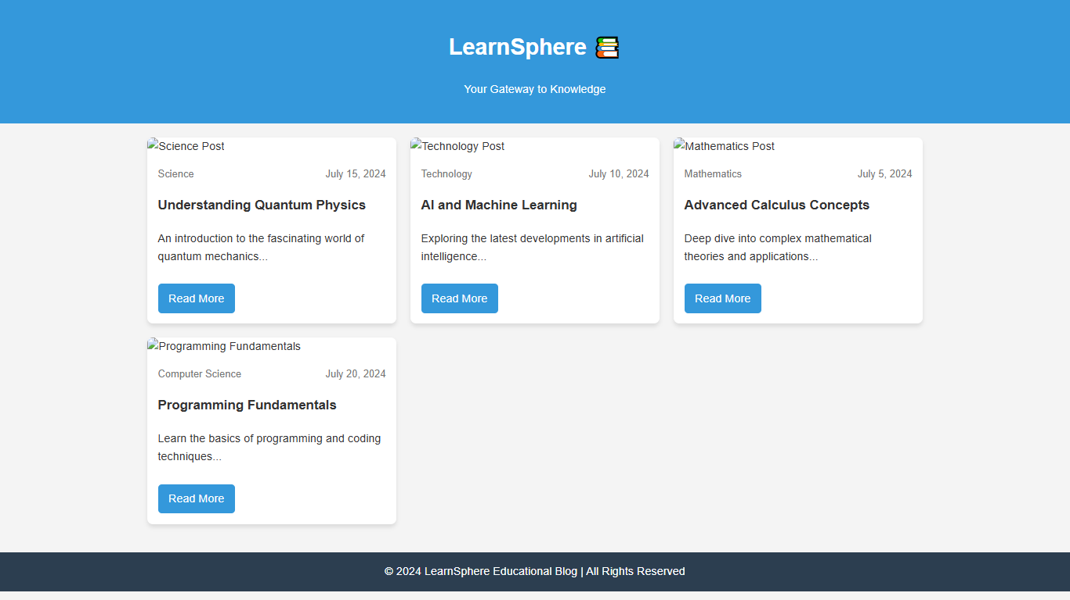

**Result:**

A clean and modern educational blog design with a focus on readability and user experience. The website utilizes a minimalist aesthetic with a focus on content, featuring a clear navigation bar, well-organized blog posts, and a visually appealing layout.

**Expt. No.:12**

**Date:**

**Design An Interactive Website For Hospital Management System**

**Aim:** To design interactive website for hospital management system

**Tools:** HTML, CSS

**Steps:**

1. Create a document of type HTML.

2. Craft a style sheet for better design.

3. Include the link of the stylesheet to the HTML file.

4. Assign a title for each page.

5. Add the required styles and attributes for the HTML tags.

6. Include action tag to navigate from one page to another.

**Output:**

<!DOCTYPE html>

<html lang="en">

<head>

    <meta charset="UTF-8">

    <meta name="viewport" content="width=device-width, initial-scale=1.0">

    <title>Hospital Management System</title>

    <style>

        body {

            font-family: Arial, sans-serif;

            line-height: 1.6;

            margin: 0;

            padding: 0;

            background-color: #f4f4f4;

        }

        header {

            background-color: #2c3e50;

            color: white;

            text-align: center;

            padding: 1rem;

        }

        nav {

            background-color: #34495e;

            padding: 1rem;

        }

        nav ul {

            list-style: none;

            padding: 0;

            margin: 0;

            display: flex;

            justify-content: center;

        }

        nav ul li {

            margin: 0 15px;

        }

        nav ul li a {

            color: white;

            text-decoration: none;

            transition: color 0.3s ease;

        }

        nav ul li a:hover {

            color: #3498db;

        }

        main {

            padding: 20px;

            max-width: 1200px;

            margin: 0 auto;

        }

        #content {

            background-color: white;

            padding: 20px;

            border-radius: 5px;

            box-shadow: 0 2px 5px rgba(0,0,0,0.1);

        }

        footer {

            background-color: #2c3e50;

            color: white;

            text-align: center;

            padding: 1rem;

            position: fixed;

            bottom: 0;

            width: 100%;

        }

        .dashboard-grid {

            display: grid;

            grid-template-columns: repeat(auto-fit, minmax(250px, 1fr));

            gap: 20px;

        }

        .dashboard-card {

            background-color: #ecf0f1;

            border-radius: 5px;

            padding: 20px;

            text-align: center;

            box-shadow: 0 2px 5px rgba(0,0,0,0.1);

        }

        .dashboard-card h2 {

            margin-bottom: 10px;

            color: #2c3e50;

        }

        .dashboard-card .count {

            font-size: 2rem;

            font-weight: bold;

            color: #3498db;

        }

    </style>

</head>

<body>

    <header>

        <h1>Hospital Management System</h1>

        <nav>

            <ul>

                <li><a href="#patients">Patient Management</a></li>

                <li><a href="#doctors">Doctor Management</a></li>

                <li><a href="#staff">Staff Management</a></li>

                <li><a href="#inventory">Inventory Management</a></li>

                <li><a href="#billing">Billing and Insurance</a></li>

            </ul>

        </nav>

    </header>

    <main>

        <section id="content">

            <div class="dashboard-grid">

                <div class="dashboard-card">

                    <h2>Total Patients</h2>

                    <div class="count">1,250</div>

                </div>

                <div class="dashboard-card">

                    <h2>Active Doctors</h2>

                    <div class="count">45</div>

                </div>

                <div class="dashboard-card">

                    <h2>Staff Members</h2>

                    <div class="count">120</div>

                </div>

                <div class="dashboard-card">

                    <h2>Available Beds</h2>

                    <div class="count">180</div>

                </div>

                <div class="dashboard-card">

                    <h2>Pending Billings</h2>

                    <div class="count">62</div>

                </div>

                <div class="dashboard-card">

                    <h2>Today's Appointments</h2>

                    <div class="count">38</div>

                </div>

            </div>

        </section>

    </main>

    <footer>

        <p>&copy; 2024 Hospital Management System</p>

    </footer>

</body>

</html>

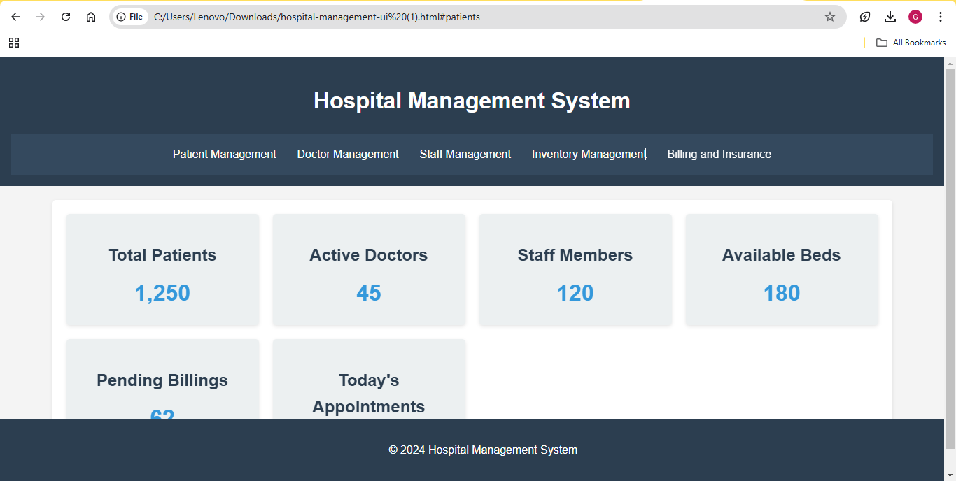

**Result:**

**A professional and user-friendly hospital management system with a clean and intuitive interface. The website features a dark theme with contrasting light text, providing a modern and sophisticated look. The layout is well-organized, with clear navigation and easy access to essential information.**

**Expt. No.:13**

**Date:**

**Design An Interactive Website For Food Selling App**

**Aim:** To design a interactive website for food selling app

**Tools:** HTML, CSS

**Steps:**

1. Create a document of type HTML.

2. Craft a style sheet for better design.

3. Include the link of the stylesheet to the HTML file.

4. Assign a title for each page.

5. Add the required styles and attributes for the HTML tags.

6. Include action tag to navigate from one page to another.

**Output:**

<!DOCTYPE html>

<html lang="en">

<head>

    <meta charset="UTF-8">

    <meta name="viewport" content="width=device-width, initial-scale=1.0">

    <title>FoodHub - Order Delicious Meals</title>

    <style>

        body {

            font-family: 'Arial', sans-serif;

            margin: 0;

            padding: 0;

            background-color: #f4f4f4;

        }

        header {

            background-color: #ff6b6b;

            color: white;

            text-align: center;

            padding: 20px;

        }

        .container {

            max-width: 1200px;

            margin: 0 auto;

            padding: 20px;

        }

        .menu-grid {

            display: grid;

            grid-template-columns: repeat(auto-fit, minmax(250px, 1fr));

            gap: 20px;

        }

        .menu-item {

            background-color: white;

            border-radius: 10px;

            box-shadow: 0 4px 6px rgba(0,0,0,0.1);

            padding: 20px;

            text-align: center;

        }

        .menu-item img {

            max-width: 200px;

            height: 200px;

            object-fit: cover;

            border-radius: 10px;

        }

        .order-button {

            background-color: #ff6b6b;

            color: white;

            border: none;

            padding: 10px 20px;

            border-radius: 5px;

            cursor: pointer;

        }

        .cart {

            background-color: white;

            border-radius: 10px;

            padding: 20px;

            margin-top: 20px;

        }

    </style>

</head>

<body>

    <header>

        <h1>FoodHub 🍽️</h1>

        <p>Order Delicious Meals Online</p>

    </header>

    <div class="container">

        <div class="menu-grid" id="menuItems">

            <div class="menu-item">

                <img src="/api/placeholder/200/200" alt="Pizza">

                <h3>Classic Margherita Pizza</h3>

                <p>Tomato sauce, mozzarella, basil</p>

                <p>₹250</p>

                <button class="order-button">Add to Cart</button>

            </div>

            <div class="menu-item">

                <img src="/api/placeholder/200/200" alt="Burger">

                <h3>Cheese Burger</h3>

                <p>Beef patty, cheese, lettuce</p>

                <p>₹180</p>

                <button class="order-button">Add to Cart</button>

            </div>

            <div class="menu-item">

                <img src="/api/placeholder/200/200" alt="Pasta">

                <h3>Creamy Alfredo Pasta</h3>

                <p>Fettuccine, cream sauce, parmesan</p>

                <p>₹220</p>

                <button class="order-button">Add to Cart</button>

            </div>

            <div class="menu-item">

                <img src="/api/placeholder/200/200" alt="Salad">

                <h3>Caesar Salad</h3>

                <p>Romaine lettuce, croutons, dressing</p>

                <p>₹150</p>

                <button class="order-button">Add to Cart</button>

            </div>

        </div>

        <div class="cart">

            <h2>🛒 Your Cart</h2>

            <div id="cartItems"></div>

            <p>Total: ₹<span id="cartTotal">0</span></p>

            <button class="order-button">Checkout</button>

        </div>

    </div>

    <script>

        const menuItems = document.querySelectorAll('.menu-item');

        const cartItems = document.getElementById('cartItems');

        const cartTotal = document.getElementById('cartTotal');

        let cart = [];

        menuItems.forEach(item => {

            const addToCartBtn = item.querySelector('.order-button');

            addToCartBtn.addEventListener('click', () => {

                const name = item.querySelector('h3').textContent;

                const price = parseInt(item.querySelector('p:nth-child(4)').textContent.replace('₹', ''));

                cart.push({ name, price });

                updateCart();

            });

        });

        function updateCart() {

            cartItems.innerHTML = '';

            let total = 0;

            cart.forEach(item => {

                const cartItemElement = document.createElement('div');

                cartItemElement.textContent = `${item.name} - ₹${item.price}`;

                cartItems.appendChild(cartItemElement);

                total += item.price;

            });

            cartTotal.textContent = total;

        }

    </script>

</body>

</html>

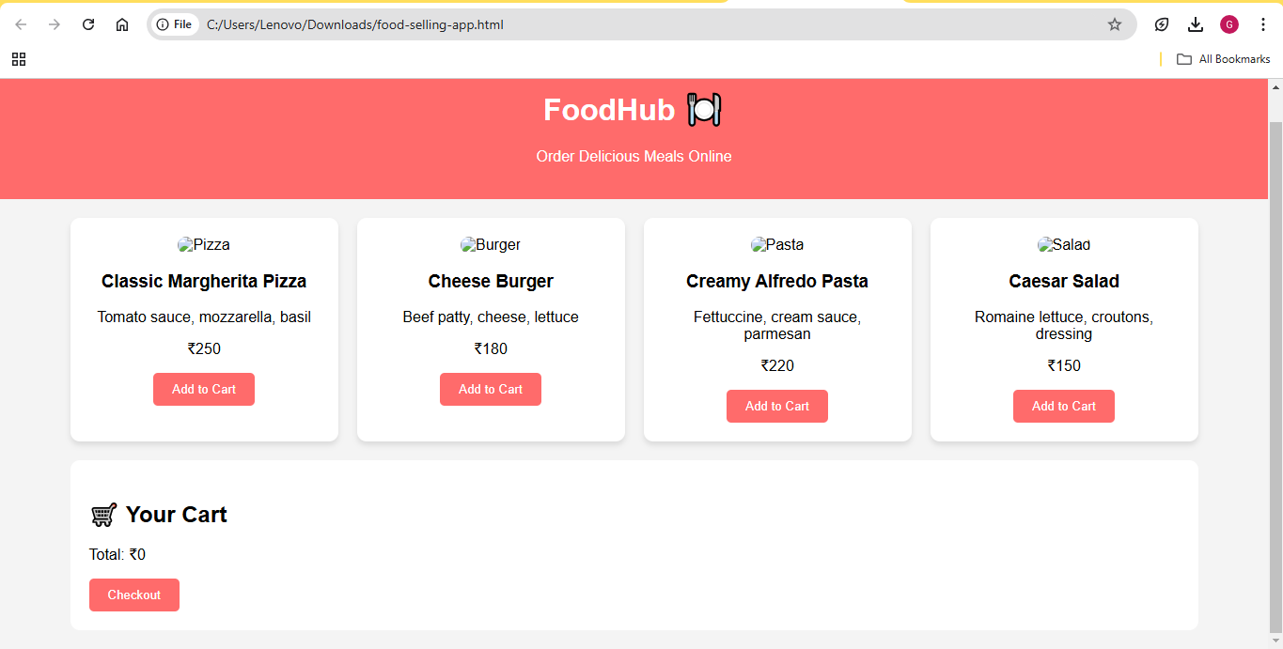

**Result**

A vibrant and user-friendly food ordering website with a clean and intuitive interface. The website uses a bright color palette to create a cheerful and appetizing atmosphere. The layout is well-organized, with clear categories and easy-to-read product descriptions.